CPE403 – Advanced Embedded Systems

# Design Assignment #05

DO NOT REMOVE THIS PAGE DURING SUBMISSION:

Name: Cameron Kirk

Email: kirkc1@unlv.nevada.edu

Github Repository link (root): https://github.com/kirkster96/DqF514-not-embedded

Youtube Playlist link (root):

<https://www.youtube.com/playlist?list=PLiqmqQ7XKuf7ArV7lO6b20D1ES5SUp0Yk>

**Follow the submission guideline to be awarded points for this Assignment.**

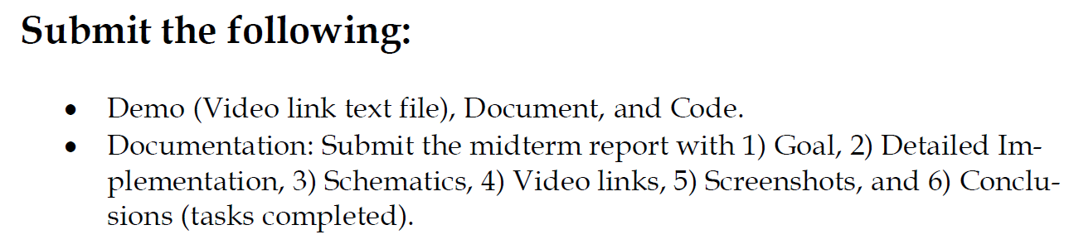

1. Goal

The goal of this assignment was to use the LPSTK as a sensor and transmit to the collector node CC1351R. A star topology network is created using the Sub-1GHz application. The sensor data from the CC1352 LPSTK is transmitting temperature, humidity and light sensor data to the collector node. In addition, the number of right BTN-2 presses should be counted and transmitted to the collector node.

1. Detailed Implementation

My implementation was achieved by using the SysConfig to configure and use the LPSTK hardware in my sensor. Specifically, I had to define the LPSTK as a definition for my project which will enable to use of all lines of code that only execute in the sensor project if the LPSTK definition is set. I also copied in the header files and function definitions for the LPSTCK and it’s dependencies. The result is that the sensor is able to use and transmit the sensor messages to the collector. The collector is modified simply to only show the messages from the sensor that include the light temp and humidity data. In addition, there is a message included to display the number of button presses.

1. Schematics

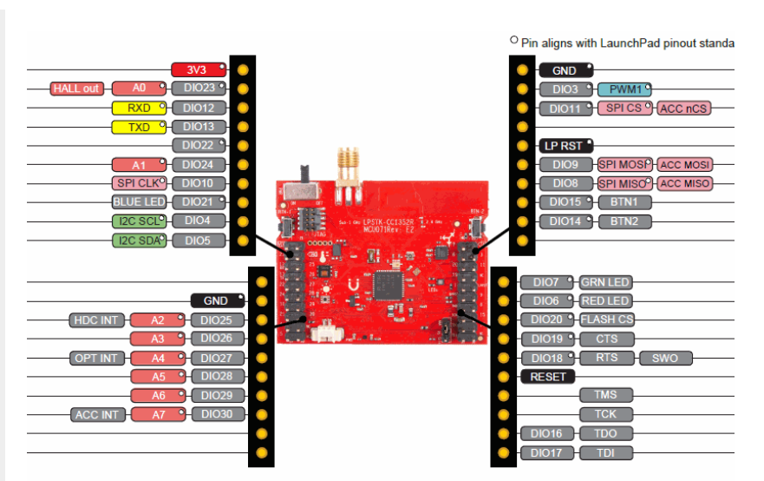

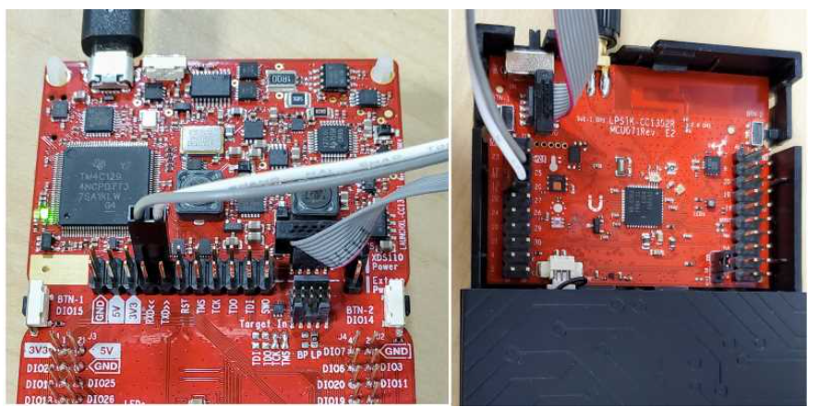

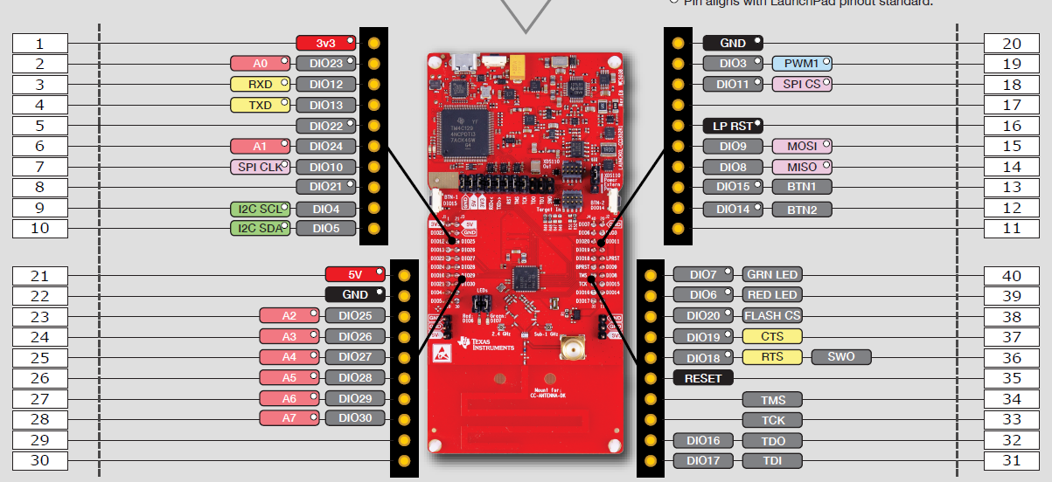

1. Screenshots

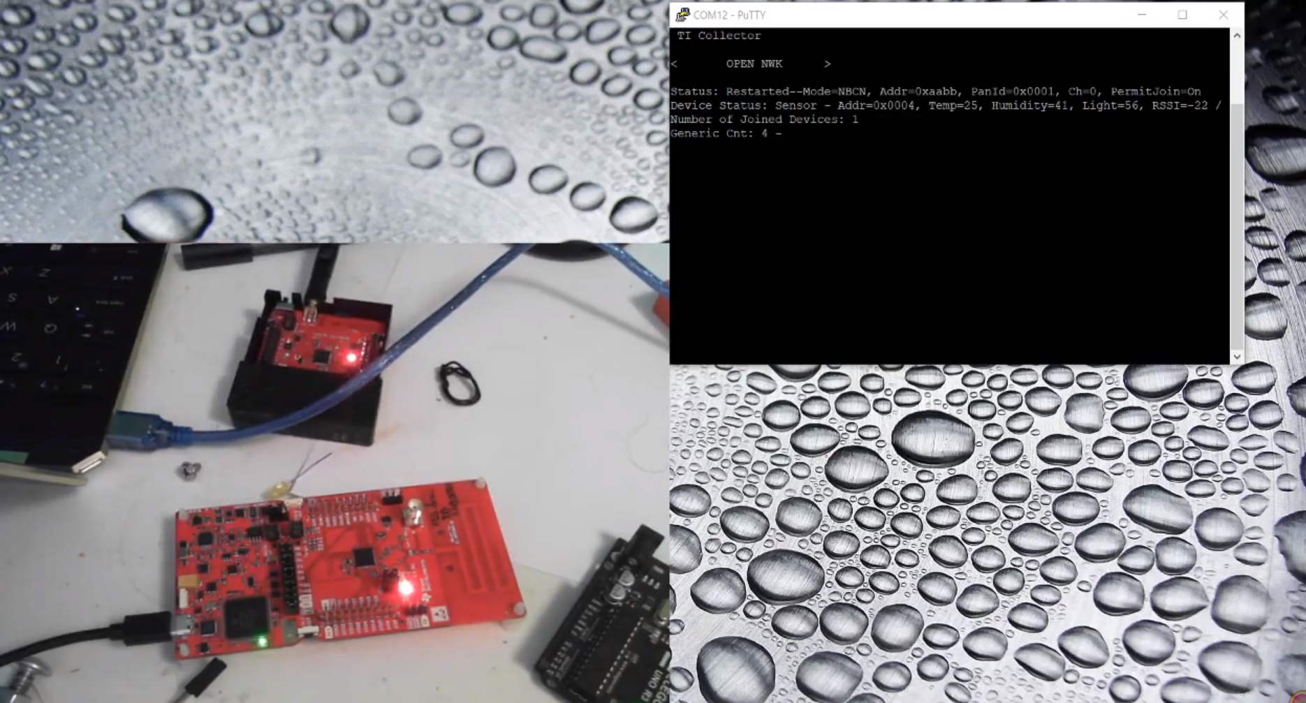

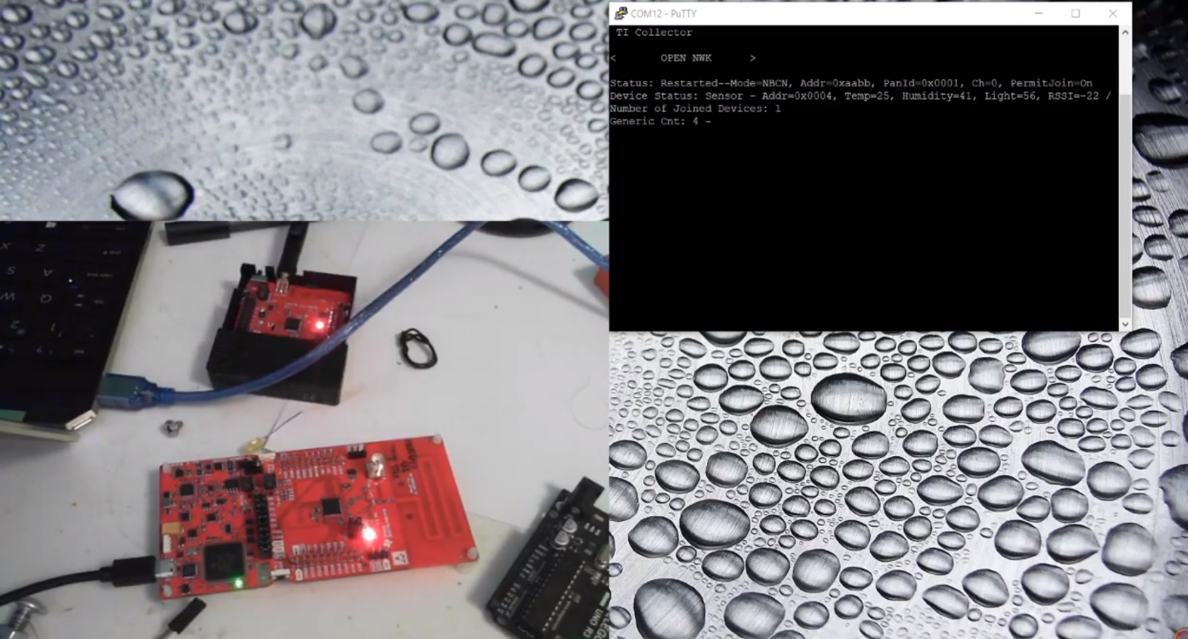

1. Video Links

<https://youtu.be/AiZyo73WGnc>

1. Conclusion

In conclusion, the TI 15.4 Stack is a very powerful tool for implementing RF applications. The sensor and collector project files that are provided for various wireless MCUs allow for fast modification and development of wireless sensor networks and systems. I was able to implement a customized sensor and collector network with minimal coding.

I understand the Student Academic Misconduct Policy - http://studentconduct.unlv.edu/misconduct/policy.html

“This assignment submission is my own, original work”.

Cameron Kirk